
Patuakhali Science and Technology University
Faculty of Computer Science and Engineering

CCE 322 :: Computer Peripheral and Interfacing Sessional
Project Report

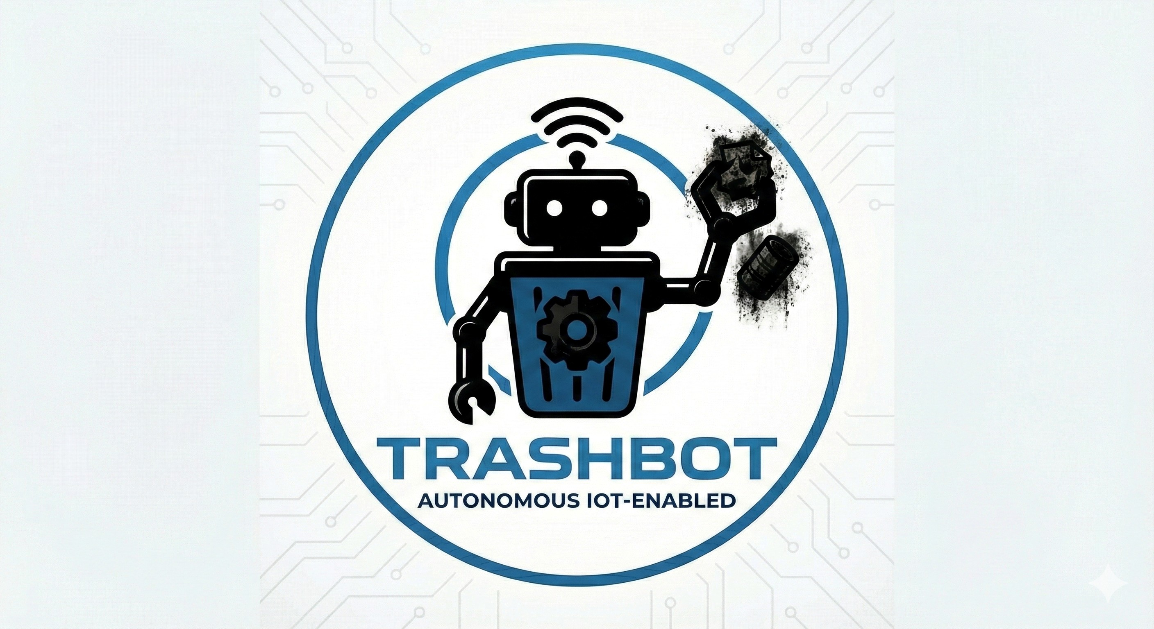
Project Title :
TrashBot
Submission Date :
17 June 2026

Submitted by, Submitted to,
- 2102008 - Md. Abdul Jobayer 1. Sarna Majumder
- 2102023 - Md. Senarul Islam Associate Professor,
- 2102042 - Md. Naimur Rahaman Depart. of Computer and Communication Engineering,
Naiem Patuakhali Science and Technology University.
- 2102049 - Prosenjit Mondol 2. Prof. Dr. Md Samsuzzaman
- 2102052 - Md. Sakib Hasan Professor,
Depart. of Computer and Communication Engineering,
Patuakhali Science and TechnologyUniversity.
Contents
1. Introduction 3
2. Objectives 3
3. Problem Statement 4
4. Scope 4
5. Methodology 4
5.1. System Architecture 5
DFNL 5
5.2. Technology Stack 5
6. Budget Estimation 5
7. Project Structure 7
7.1 Circuit Diagram 7
7.2 Flowchart 8
8 Future Plan 9
8.1 Improved navigation (Lidar & SLAM) 9
8.2 How to integrate the Smart City Ecosystem. 9
8.3 Sustainable Power & Autonomy 9
8.4 Swarm Robotics Capabilities 9
9 Conclusion 10


TrashBot
TRASH COLLECTING ROBOT WITH IOT TECHNOLOGY

Introduction
With the swift development of Robotics, this problem of public cleanliness can be solved. In some highly populated areas, waste collection is done manually, which can be a time-consuming and inefficient process. To overcome this we introduce TRASHBOT, an autonomous IoT (Internet of Things) robot for the easy collection of waste in public areas.
TRASHBOT combines the autonomous navigation system with the robotic arm that is responsible for detecting, collecting and segregating the waste. The operational modes include Autonomous Mode (the system autonomously navigates around obstacles to reach a destination) and Manual Mode (the system is controlled by a person from afar using an Android app). The mechanical automation and real-time IoT data monitoring make TRASHBOT an effective, sustainable, and affordable way to keep cities cleaner.

Objectives

The main objective of the TRASHBOT project is the modernization of public sanitation: the development of an autonomous, low-cost robotics solution for waste management which will minimize the need for manpower.
The objectives of this research are:
• To Design an Autonomous Navigation System:In this case, the autonomous navigation system would permit a mobile rover to design an autonomous navigation system to move independently, plan paths and avoid obstacles on using ultrasonic sensors and differential steering logic.
• To Implement Robotic Waste Collection: To design a multi-degree-of-freedom robotic arm using a high torque servo motor which will detect, grab and lift waste from the ground.
• To Enable Smart Segregation: To incorporate metal proximity sensors that are capable of automatically recognizing between metallic and non-metallic waste and, accordingly, sorting them into separate bins inbuilt within the system.
To Integrate IoT Connectivity: To enable the operation of the model in two modes (Autonomous & Manual) and real time remote monitoring using an Android Application (Blynk) by using ESP8266 Wi-Fi module.
To Ensure Efficient Power Management: To develop a reliable power supply solution by employing high capacity Li-Ion batteries and DC-DC step-down power supply for continued power use in the field.

Problem Statement

The TRASHBOT system will solve the following problems that are important in the present waste management system of urban areas:

- The increase of uncollected refuse in high density public places, like rails station, bus terminal, pollutates the environment, becomes breeding ground for pathogens and causes severe sanitary risks.
Conventional Manual Sanitation is labour intensive, expensive and not efficient enough to cover high quantities at a large scale. Moreover, it puts sanitation workers at risk of exposure to dangerous (unhygienic) conditions and toxic substances.

- The current automated cleaning technologies are mostly limited to indoor conditions with a structured layout. They are not autonomous and adaptable enough to work in the unpredictable environments outside and have no inbuilt telemetry (IoT) for immediate fleet management.

- Scalability & Consistency Challenges: Other problems are the reliance on human effort to ensure that sanitation standards are consistently met 24x7, especially when dealing with large public infrastructure which is simply not feasible logistically and/or financially to monitor all the time.

Scope

TRASHBOT project mainly studies the design and prototyping of a semi-autonomous rover for
Dry Waste Management in public areas. The minimal set of functions covers:
- Dual-Mode Operation: Autonomous Obstacle Avoidance and Manual Teleoperation using an IoT enabled Android app.
- Automated Collection & Segregation: Designing an automated system of a robotic arm for physical collection of waste materials and a waste material segregation mechanism based on inductive sensing.
- Remote Telemetry: Connection of live video transmission and system status to remote operators.
- Prototype Limitations: Being optimized for flat terrain and solid dry waste, detection by the sensor is around 30 cm.

Methodology

The TRASHBOT project is based on an agile prototyping approach, where the hardware of the
robot is divided into three subsystems: Locomotion, Manipulation and IoT Communication.

System Architecture

DFNL
It is based on a centralized control model using the Raspberry Pi 3 Model B.
• Processing & IoT: The Raspberry Pi runs Python control logic, controls video streaming and sends telemetry to the Blynk cloud using the built in Wi-Fi.
• Input/Output: It process data from ultrasonic sensor & proximity sensor and drive DC motor (Navigation) and Servo motor (Waste collection).
Power: 11.1V Li-Ion battery with buck converters provide for stable power distribution to all components.

Technology Stack

Key hardware and software components include:
Category | Component / Technology
Controller | Raspberry Pi 3 Model B (Quad Core 1.2GHz)
OS & Logic | Raspbian OS / Python
Connectivity | Wireless Internet (802.11n) Built-in
Sensors | HC-SR04 (Obstacle), Inductive Proximity (Metal)
Actuation | MG995 Servos & L298N Motor Driver
Power | 11.1V 10000mAh Li-Ion, Buck Converters
Interface | Blynk IoT App, IP Webcam
Chassis | 4-Wheel Differential Drive Platform
Table 1: Technology Stack of TRASHBOT

Budget Estimation
The following is a detailed breakdown What follows is a detailed breakdown of the estimated costs of the hardware components needed for the TRASHBOT project.

Category | Component Name | Unit  Price  (BDT) | Qty | Total (BDT)
Controllers | Raspberry Pi 3 Model B (1GB) | 10,199 | 1 | 10,199
 | Raspberry Pi AI Camera | 6,880 | 1 | 6,880
 | ESP-32 Development Board | 550 | 1 | 550
Motors & Drivers | Gripper | 680 | 1 | 680
 | Tower Pro MG995 servo motor | 354 | 2 | 708
 | Gear Motor with Wheel | 155 | 4 | 620
 | Motor Driver | 890 | 1 | 890
Sensors | Ultrasonic Sonar Sensor | 110 | 6 | 660
 | Metal Proximity Switch Sensor | 390 | 1 | 390
 | IR LED Sensor | 150 | 1 | 150
 | LED Sensor | 99 | 1 | 99
 | Alcohol Gas Sensor | 144 | 1 | 144
 | Dual IR Flame Sensor | 450 | 1 | 450
 | Water Sensor | 350 | 1 | 350
 | Vibration Sensor | 380 | 1 | 380
Power | Transformer 12V 3A | 390 | 1 | 390
 | Buzzer | 15 | 1 | 15
Mechanical & Misc | Full-Size Breadboard | 120 | 2 | 240
 | Half-Size Breadboard | 75 | 2 | 150
 | Jumper Wires (Male-Male) | 100 | 4 | 400
 | Li-ion Battery | 260 | 4 | 1,040
 | Solar Panel | 350 | 1 | 350
 | Battery case | 50 | 1 | 50
 | Display | 340 | 1 | 340
Module | GSM GPRS Module | 1,560 | 1 | 1,560
 | GPS Module | 440 | 1 | 440
 | Grand Total Estimated Cost |  |  | 28,125  BDT
Table 2: Detailed Budget Estimation

7. Project Structure

Circuit Diagram

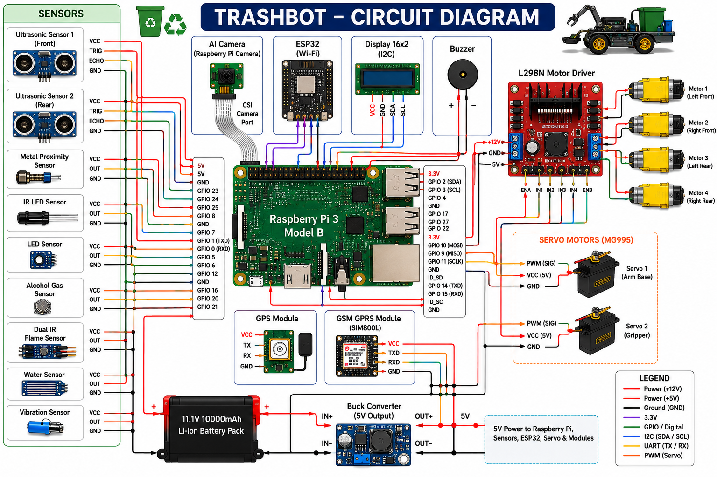
Figure 01: Project Circuit Diagram

Flowchart
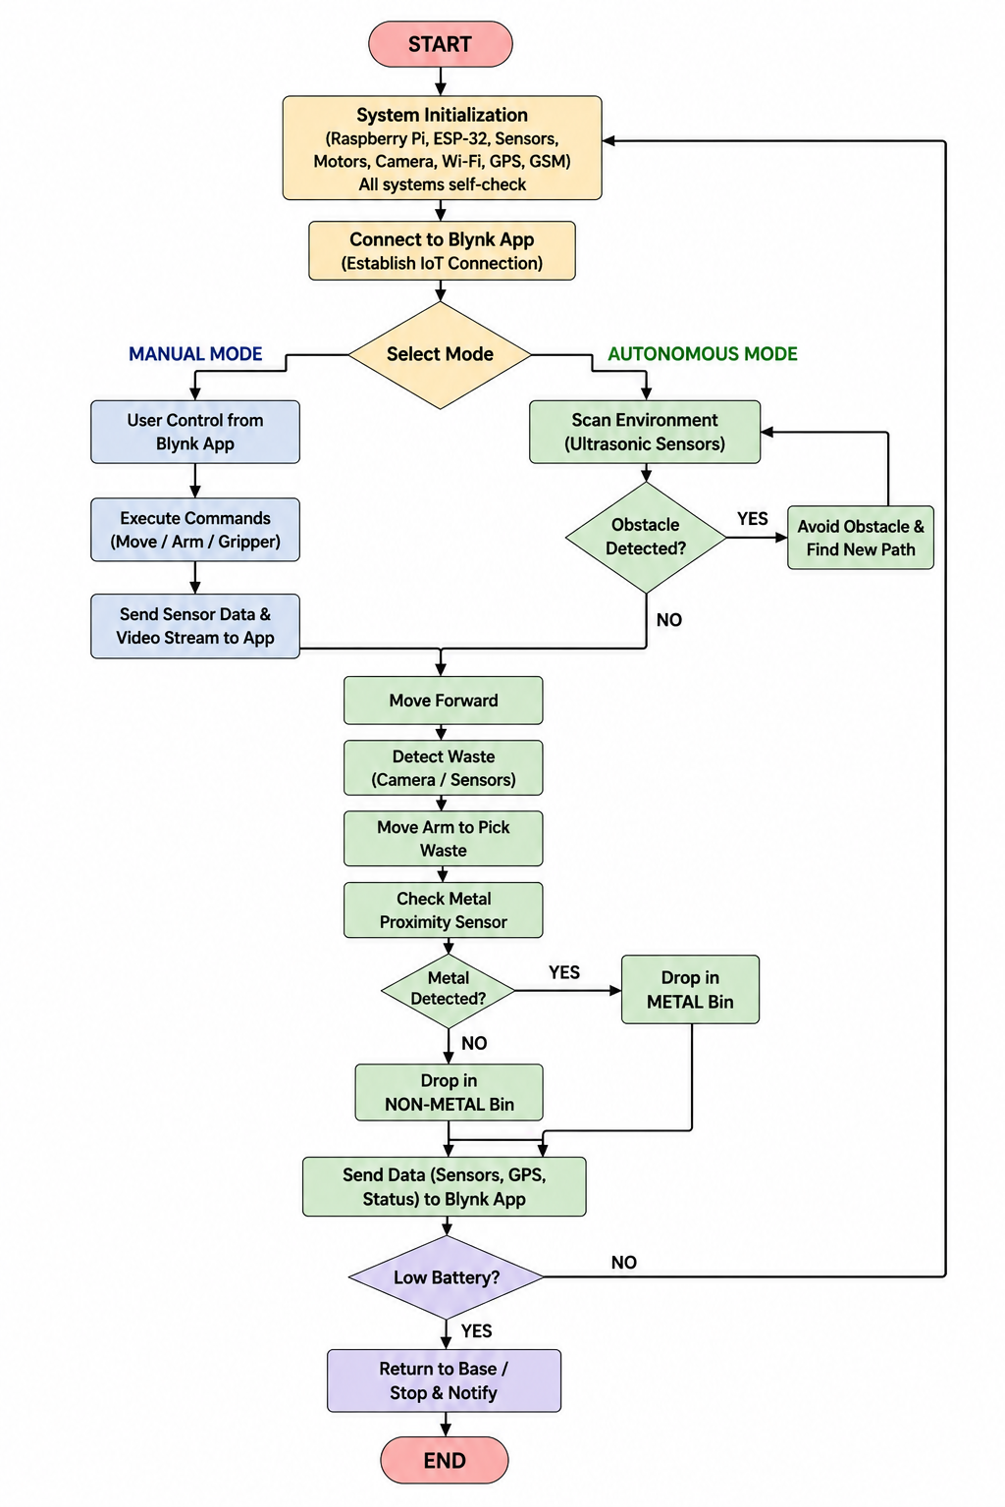
Figure 02: Project Flowchart

Future Plan

The core systems for autonomous navigation and object detection based on YOLO have already been developed and are being used, while further research and development is currently underway to make them scalable, energy efficient and integrated into the ecosystem.

Improved navigation (Lidar & SLAM)

- Lidar Integration: Lidar Integration with high resolution mapping, replacing ultrasonic sensors with Lidar (Light Detection and Ranging).

- SLAM Implementation: The implementation of Simultaneous Localization and Mapping (SLAM) will enable the robot, in complex and dynamic (crowded market) environments, to navigate with greater accuracy than the current differential steering logic allows.

.

How to integrate the Smart City Ecosystem.

- Centralized Dashboard: Creating a dashboard at the municipal level to combine data from several units of TRASHBOT. This would enable city officials to get “heat maps” of areas with a high concentration of waste and schedule sanitation accordingly.

- 5G / LoRa WAN Connectivity: Transitioning from Wi-Fi to LoRa WAN / 5G module connectivity to support telemetry transmission over long distances across a city district without the need for local hotspots.

Sustainable Power & Autonomy

- Solar Hybrid System: With the inclusion of flexible solar panels on the chassis, the Solar Hybrid System can also help to extend battery life during daylight hours.

- Autonomous Docking: Investigate the possibility of creating an automatic charging station that the robot can come back to in order to charge it's battery automatically, thus allowing it to work around the clock.

Swarm Robotics Capabilities

• Fleet Coordination: “Swarm Mode” Through a mesh network between multiple TRASHBOT units, the robots can communicate. Each robot can communicate to other robots if it is detecting an overload of waste materials so that it can send a signal to its surrounding robots to help it clean the trash in large public areas so that it is cleaned efficiently

Conclusion

The TRASHBOT project has successfully showcased the viability of an IoT-based, autonomous waste management system aimed at tackling urban sanitation issues. The combination of the computational capabilities of the Raspberry Pi 3 Model B and the mechanical capabilities of the actuators along with the sensor fusion ensures that the system is able to fill the gap between manual labour and smart automation. The conclusion of this prototype is the validity and feasible cost of automated hazardous waste collection. Dual-mode operation allows the flexibility in dynamic public spaces; the intelligent segregation mechanism encourages sustainable recycling processes right at the source. In short, TRASHBOT is a solid groundwork for smarter, cleaner cities to provide an upcoming waste management blueprint with great scalability.

